**Bahria University, Lahore Campus**

Department of Computer Sciences

Lab Journal 05

**(Spring 2023)**

|  |  |  |
| --- | --- | --- |
| Course: | **Computer Architecture & Organization Lab** |  |
| Course Code: | CEL 221 | Max Marks: 30 |
| Faculty’s Name: | Maryam Munawar | Lab Engineer: |

Name: _AFFAN AHMAD___ Enroll No: _03-134221-003___

## Lab Tasks:

### Task1: 5 Minutes

Write down a MIPS program that utilizes the max function.

**.data**

**a: .asciiz "enter the first number :"**

**b:.asciiz "enter the second number :"**

**c:.asciiz "1 for first number is greater then second num else 0 :"**

**.text**

**li $v0,4**

**la $a0,a**

**syscall**

**li $v0, 5**

**syscall**

**move $s2,$v0**

**li $v0,4**

**la $a0,b**

**syscall**

**li $v0, 5**

**syscall**

**move $s3,$v0**

**sgt $s1,$s2,$s3**

**li $v0, 4**

**la $a0, c**

**syscall**

**li $v0, 1**

**move $a0, $s1**

**syscall**

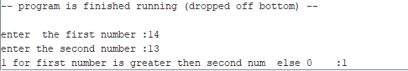

### Task2: 5 Minutes

## Write a program to convert Fahrenheit to Celsius using the formula below:

## Fahrenheit = Celsius * 9.0 / 5.0 + 32.0;

## Write a function for this temperature conversion. Celsius value is be passed into the function as single-precision data and Fahrenheit value is returned also in single-precision. Remember to follow all the floating-point function conventions.

.data

a: .asciiz "enter the Celsius :"

b:.asciiz "enter the second number :"

c:.asciiz "the result is :"

.text

li $v0,4

la $a0,a

syscall

li $v0, 5

syscall

move $s2,$v0

mul $s0,$s2,9

div $s0,$s0,37

li $v0, 4

la $a0, c

syscall

li $v0, 1

move $a0, $s0

syscall

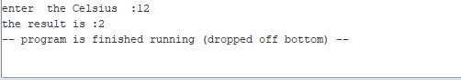

### Task3: 5 Minutes

Write a program to get marks as input from user and calculate GPA as per HEC policy.

.data

number1: .double 3.14

number2: .double 2.71

c:.asciiz "your GPA is :"

.text

ldc1 $f2, number1

ldc1 $f4, number2

add.d $f12, $f2, $f4

li $v0,4

la $a0,c

syscall

li $v0,3

syscall

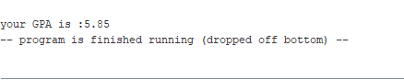

**Lab Grading Sheet :**

|  |  |  |  |
| --- | --- | --- | --- |
| **Task** | **Max Marks** | **Obtained Marks** | **Comments(*if any*)** |
| a. | 5 |  |  |
| b. | 5 |  |  |
| c. | 5 |  |  |
|  |  |  |  |
| **Total** | **15** |  | **Signature** |

**Note : Attempt all tasks and get them checked by your Instructor**